CURRICULUM VITAE

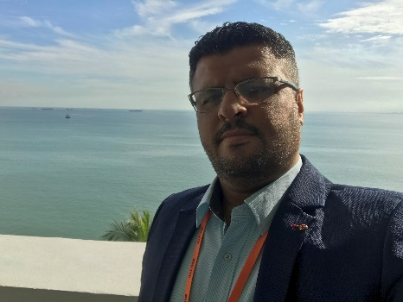

Mohannad N. Sayaheen, Ph.D

Personal Details:

Name: Dr. Mohannad N. M. Sayaheen
Nationality: Jordanian
Date of Birth: 26/3/1981
Gender: Male
Marital Status: Married
Present address: Irbid, Jordan.
Telephone: Mobile: 00962/ (0) 776044617
E-mail: mohannadnajehsayaheen@gmail.com

Education:

- PhD in Translation Studies from University of Science Malaysia. My Dissertation is entitled A STUDY OF THE CULTURAL TRANSLATION NORMS OF CHILDREN’S LITERATURE FROM ENGLISH INTO ARABIC

- MA in Applied Linguistics from Jordan University of Science and Technology, Jordan.

- BA in English for specific Purposes (ESP) from Jordan University of Science and Technology, Jordan.

Experience:

- Currently: A part time assistant professor of translation in the English Department at Al – Ahliyya Amman University (AAU) (Part-time Faculty). I am teaching MA students a course in translation (Translation Technologies).

- (2016- present) Arabic Translator and Reviewer FM Global (Vistatec Ltd)

- (2014- present) Arabic Translator and Reviewer Expedia (Vistatec Ltd)

- (2011- 2020) Arabic Translator and Reviewer (XL), Lead Reviewer and Jetsetter Coordinator Lite (Vistatec Ltd) (Areas of Specialization: Insurance, legal, engineering, risk reports, safety issues, Marketing, Financial, Travel and Tourism, education, Sports and Maps).

- (2009-2012) English lecturer at The University of Ha’il, KSA. I taught intensive English language courses, including the four basic skills, to newly admitted students at the university.

- (2016- 2018) Arabic Translator and Reviewer (XL) at Moravia (work for UBER projects).

- (2007-2008) English instructor at The Hashemite University.

Course Teaching and co-ordination:

- An assistant professor of translation in the English Department at Al – Ahliyya Amman University (AAU) (Part-time Faculty).
- English instructor at The Hashemite University
- English lecturer at The University of Ha’il, KSA. I taught intensive English language courses, including the four basic skills, to newly admitted students at the university.

Publications

- Sayaheen, M., Mahadi, T. S. T., & Sayaheen, B. (2019). FOREIGNIZING OR DOMESTICATING ENGLISH CHILDREN’S LITERATURE TRANSLATED INTO ARABIC: THE CASE OF ALICE’S ADVENTURES IN WONDERLAND. International Journal, 2(8), 175-187.

- Sayaheen, M. N., & Mahadi, T. S. T. (2020). FOREIGNIZING AND DOMESTICATING RELIGIOUS TERMS AND EXPRESSIONS IN CHILDREN’S LITERATURE. e-Bangi, 17(9).

- Sayaheen, M. N., & Mahadi, T. S. T. FOREIGNIZING VS. DOMESTICATING REFERENCES TO FLORA AND FAUNA IN CHILDREN’S LITERATURE. Journal of Language and Communication (Accepted for Publication)

Skills and Training

- Excellent skills in translation and terminology software including: SDL Trados Studio, SDL MultiTerm Desktop, MemoQ, Workbench and Memsource Cloud.
- Excellent computer skills: Microsoft windows operating systems, office applications and website creation.
- Excellent E-learning skills.
- Excellent language interpreting labs training skills.

Awards, Professional Developments, and Other Activities:
- I have been awarded The FLTA Award: Fulbright Language Teaching Assistants Award at Santa Clara University (California) for the academic year 2006/2007. The Fulbright Foreign Language Teaching Assistant (FLTA) Program is an opportunity for young teachers of English to refine their teaching skills, increase their English language proficiency and extend their knowledge of the cultures and customs of the United States while strengthening the instruction of foreign language at U.S. colleges and universities.

- Foreign Language Teaching Assistant Workshop in Cairo, Egypt July 2006. Sessions in this workshop have been developed to provide the participants with skills needed to successfully adjust to teaching and studying in a U.S. post-secondary educational institution.
- FLTA Foreign Language Teaching Assistant Workshop in Washington, DC December 2006.

Referees:
1- Dr Fayeq Oweis, Faculty of modern languages
Email: Foweis@scu.edu

2- Dr Thaer Al qadi, Faculty of science and arts
Email: Alkadi@hotmail.com

3- Prof. DR. TENGKU SEPORA TENGKU MAHADI, Universiti Sains Malaysia
Email: tsepora@usm.my

